Data sheet for crane wheels

SINGLE-FLANGE | DOUBLE-FLANGE | KEY
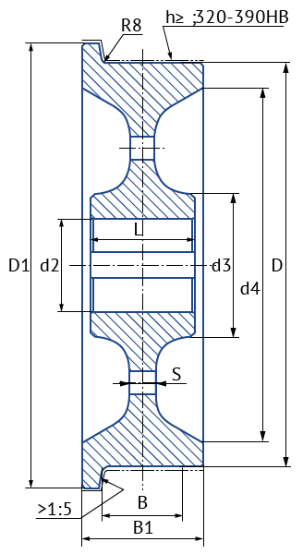 | 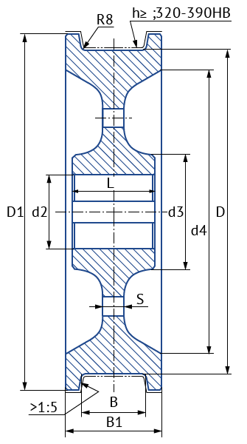 | 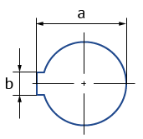
Fill in the sizes, please

mm |  |  |  |  |  |  |  |  |  |  | Steel grade | Tread surface hardness | Qty.
D* | D1* | B* | B1* | L | d2* | d3 | d4 | S | a | b
* | * | * | * |  | *
*Compulsory sizes for an accurate cost calculation
Company details

Company name:
Address:
Phone/fax:
E-mail:
Contact person:

Dear Partners!
Entrusting us the production of crane wheels, You do not only solve questions of supply of quality spare parts for Your machinery, but also acquire by the company "El-Kran" a long-term and committed Assistant, because we always care for an end result and a strong "Thank you" as a summary of each completed Contract.
LLC "El-Kran"
8 (800) 100 33 17 – free calls across Russia
+7 (495) 664 51 17; +7 (4842) 75 10 77
E-mail: sales@el-kran.ru; Web: www.el-kran.ru

